**SECTION A (60 Marks)**

Answer only **three** questions from this section.

1. Carbon, silicon, germanium, tin and lead are elements of group (IV) of the periodic table.
2. (i).Write the **outermost electronic configuration** of group (IV) elements. (01 mark)

(ii).State the **oxidation states** of group (IV) elements. (01 mark)

(iii).State how the **stability of the oxidation states** vary down the group (IV) elements. (02 marks)

1. Describe the **reactions** of the elements with:
2. Water. (06 marks)
3. Concentrated sulphuric acid. (06 marks)
4. Write **equations** for the reactions between:
5. Silicon (IV) oxide and hot concentrated hydrofluoric acid. (01½ marks)
6. Trileadtetraoxide and warm dilute nitric acid. (01½ marks)
7. Tin (II) chloride solution and iron (III) sulphate solution. (01½ marks)
8. a) Define the term **relative atomic mass**. (02 marks)
9. Explain how relative atomic mass can be determined by the mass spectrometer. (09 marks)
10. The mass spectrum of an **element T** contained four lines at mass/charge ration of **54**, **56**, **57** and **58**.
11. Explain what the term relative intensities mean and why the mass spectrum of **element T** contains 4 lines. (03 marks)
12. Calculate the relative atomic mass of **element T**. (02 marks)
13. Explain why the values of relative atomic mass have no units.(01 mark)
14. Thorium decays according to the following equation:

+  X + 𝛃 Y + 𝛃 Z

Determine the **mass** and **atomic numbers** of **X**, **Y** and **Z**. (03 marks)

1. (a).A **gaseous alkene, Y** diffuses **0.57735 times** faster than nitrogen gas. Determine the **molecular formula** of alkene, Y. (03 marks)
2. On ozonolysis followed by hydrolysis **alkene, Y** produced **propanal** and **propanone** as the major organic products. Identify **alkene, Y**. (01 mark)
3. Write the equation and suggest a mechanism for the reaction between:
4. **Alkene, Y** and benzene in the presence of an acid. (04 marks)
5. **Alkene, Y** and bromine water. (04 marks)
6. **Propanal** and phenylhydrazine in acidic medium. (04 marks)
7. Using equations only show how **alkene, Y** can be synthesized from propyne. (04 marks)
8. a) (i) Define the term **lattice energy**. (01 mark)

(ii)State **two factors** that affect lattice energy. (01 mark)

b) Thermodynamic data for aluminium,fluorine and aluminium fluoride are given below.

The standard enthalpy of formation of aluminium fluoride = -1,301kJ/mol

The standard enthalpy of atomization of aluminium = +314kJ/mol

The standard enthalpy of bond dissociation of fluorine = +158kJ/mol

First ionization energy of aluminium = +577kJ/mol

Second ionization energy of aluminium = +1,820kJ/mol

Third ionization energy of aluminium = +2,740kJ/mol

First electron affinity of fluorine = -348kJ/mol

1. Draw an **energy level diagram** for formation of aluminium fluoride. (04½ marks)
2. Use the diagram you have drawn to calculate the **lattice energy** of aluminium fluoride. (03 marks)
3. Given that the hydration energies of aluminium, Al3+ ions and fluoride,F- ion are **-4,690** and **-364kJ/mol** respectively.Calculate the enthalpy of solution of aluminium fluoride and comment on the solubility of aluminium fluoride in water. (04½ marks)
4. The electrode potentials of aluminium and zinc are shown below.



The two half cells are combined to form a cell.

1. Write the overall cell reaction. (01½ marks)
2. Calculate the e.m.f of the cell. (01½ marks)
3. Calculate the **standard free energy** for the cell. (02 marks)
4. State whether the cell is **feasible** or **not**. Give a **reason** for your answer. (01 mark)

**SECTION B (40 Marks)**

Answer only **two** questions from this section.

1. (a).Complete the following equations and in each case outline a mechanism for the reaction.

    

1. Write the IUPAC names of the products in a (i) and (ii) above. (02 marks)
2. (a) 2-nitrophenol and 4-nitrophenol can be prepared by reacting phenol with dilute nitric acid.
3. Write equation for the reaction. (01 mark)
4. Which one of the two products has higher melting point. Explain your answer. (06 marks)

(b)2-nitrophenol and 4-nitrophenol can be separated by steam distillation.

1. What is meant by the term steam distillation? (01 mark)
2. With the aid of a well-labelled diagram, describe how a mixture of 2-nitrophenol and 4-nitrophenol can be separated by steam distillation. (04 marks)
3. When **50.0g** of a mixture of 2-nitrophenol and 4-nitrophenol was steam distilled at **97ᵒC** and **750mmHg**, a distillate was found to have a mass of 35.0g.The vapour pressure of water at **97ᵒC** is **654mmHg**.Determine the p**ercentage** by **mass** of 4-nitrophenol in the mixture. (04 marks)
4. State two advantages of steam distillation over fractional distillation. (02 marks)
5. (a).(i) Explain the term colligative property. (01½ marks)

(ii)State four colligative properties of a solution. (02 marks)

1. . (i) Describe how the molecular mass of a substance can be determined by elevation of boiling point method. (07 marks)

(ii)State three limitation of the method. (01½ marks)

1. Calculate the **boiling point** of an aqueous solution of urea, [CO(NH2)2] of concentration **12g/dm3** at a pressure of **101.3kPa**. (04 marks)

[Assume that the volume of the solute is negligible compared to that of the solution. The boiling point elevation constant for water = **0.52ᵒC/mol/kg**]

1. (i) Explain the term mole fraction. (01 mark)
2. Calculate the **mole fraction** of sodium chloride in an aqueous solution containing **10g** of sodium chloride per **100g** water. (03 marks)

1. Explain each of the following observations.
2. Dimethylamine is a stronger base than phenylamine. (04 marks)
3. The first ionization energy of aluminium is less than that of magnesium. (03 marks)
4. The pH of a solution of chromium (III) chloride in water is less than 7. (03 marks)
5. Carbon dioxide is a gas at room temperature while silicon dioxide is high-melting solid. (03 marks)
6. 1-bromohexane undergoes nucleophilic substitution whereas bromobenzene does not. (04 marks)
7. When solid lead (IV) chloride is added to water, white fumes are observed and a brown precipitate is formed. (03 marks)

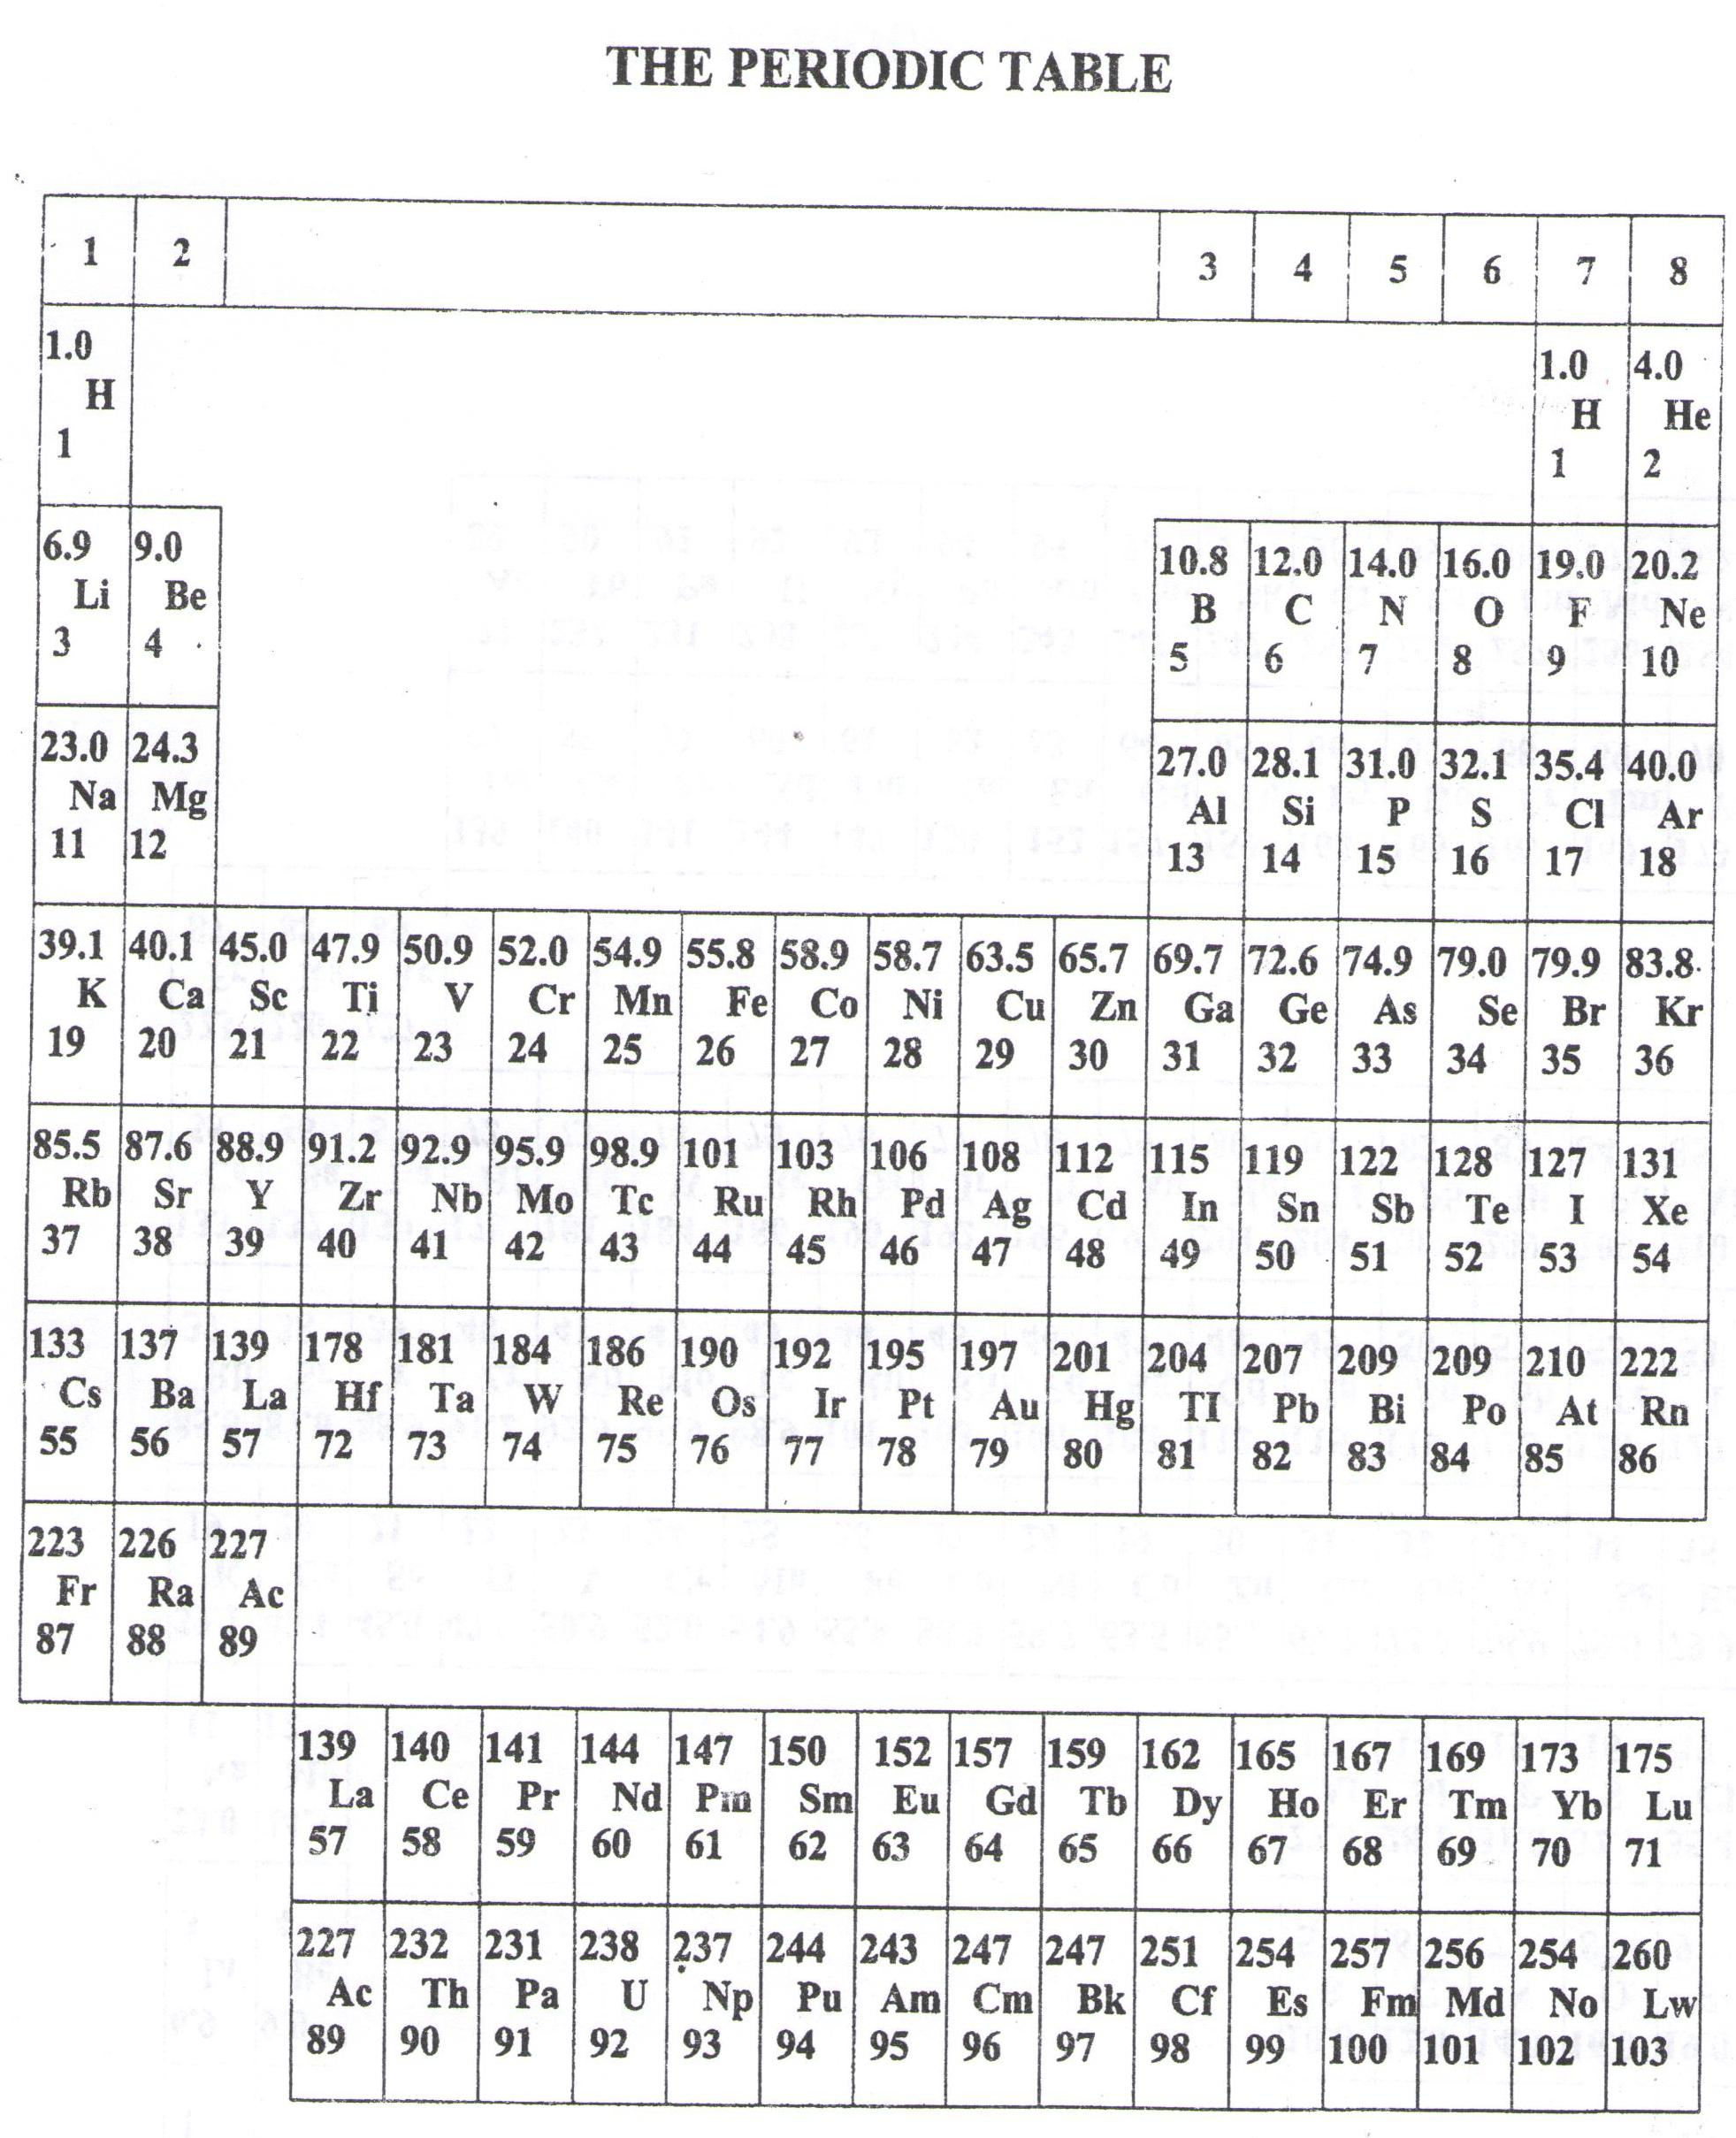

* ===END===

WELCOME TO SENIOR SIX, YEAR 2023

This is the last page of the printed paper, Page 05